Assigment : Load Balancer (Application Load Balancer)

Step 1: Create VPC
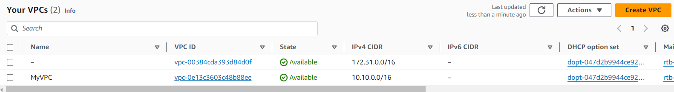

Step 2: Create Subnet (Create 4 subnet 2 for audio , 2 video)

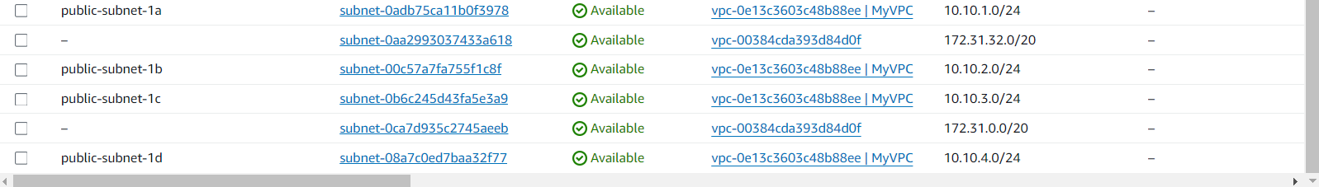

Step 3: Create IGW and Attach with VPC

Step 4: Now attach IGW And subnet with Route table
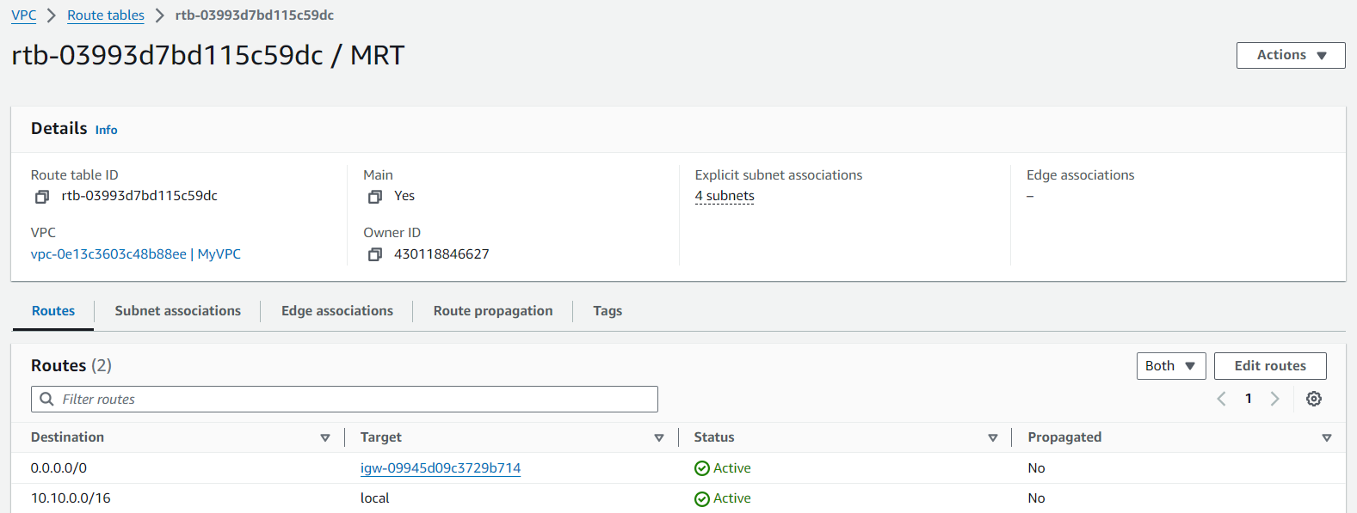

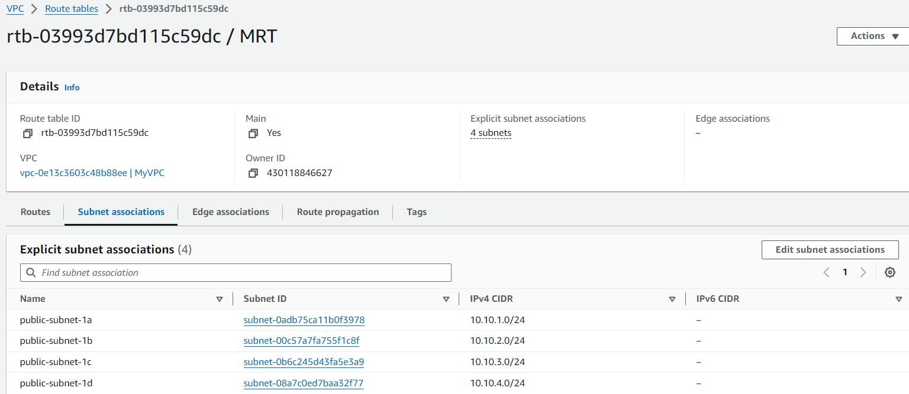

Step 5: Launch ec2 instance and add below script in each server of nginx

Script: Add in user data in each server
#!/bin/bash
sudo yum install nginx -y
sudo systemctl start nginx
sudo systemctl enable nginx

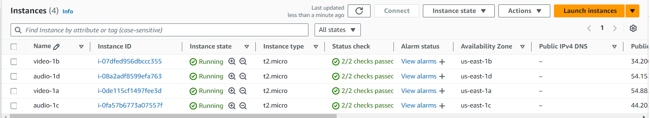

Step 6:Now login to each server and create on two server create videos directory and remaning 2 server create audios directory on below path(path based directory)
Path: /usr/share/nginx/html
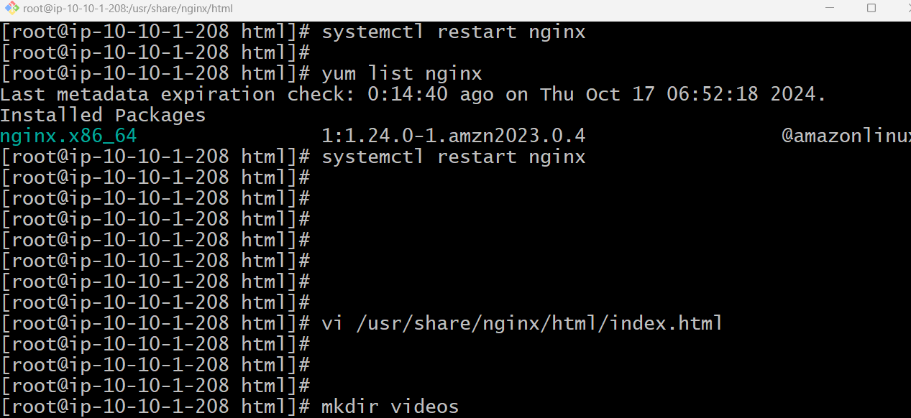

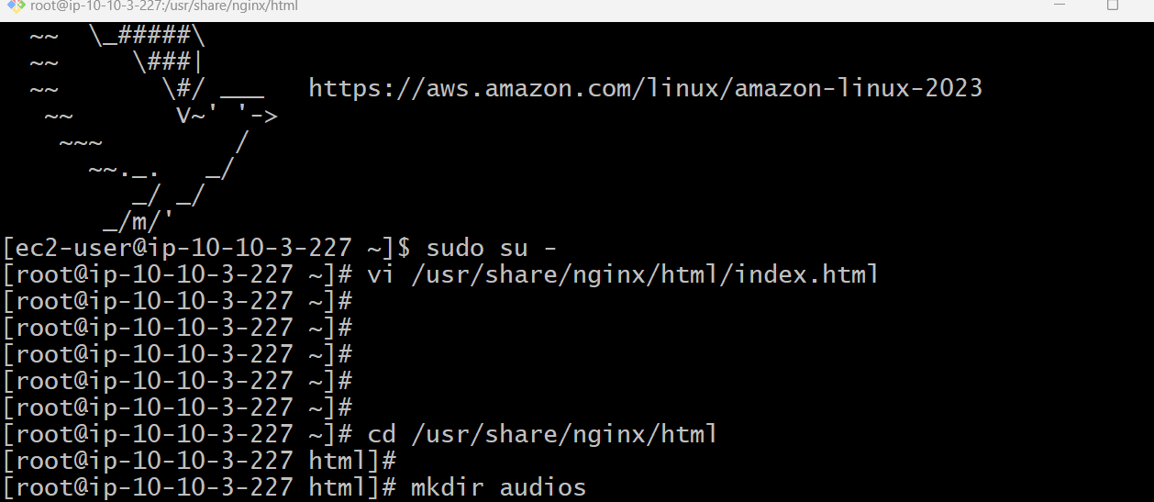

Step 7: Now move index.html to videos directory and audios directory and deploy your application
In index.html

Path: /usr/share/nginx/html
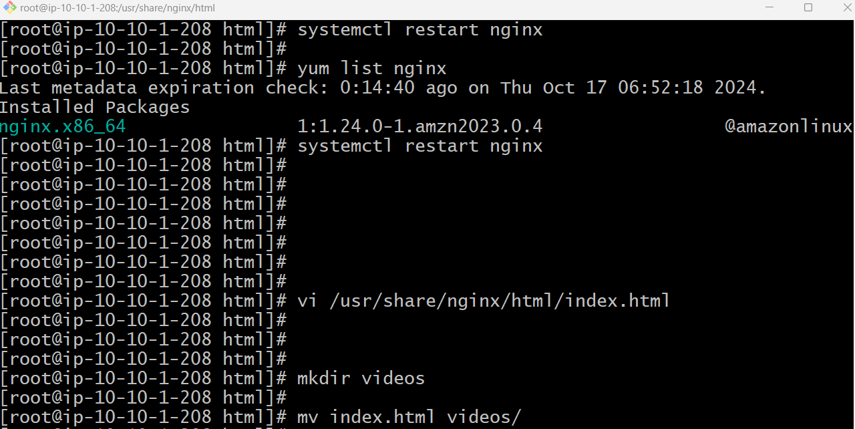

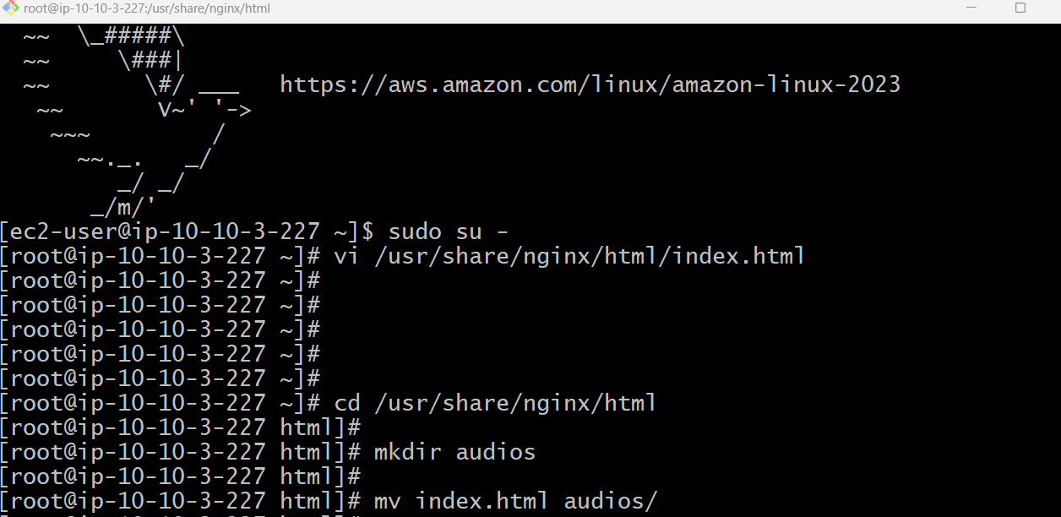

Step 8: Now create index.html on below path

Path: /usr/share/nginx/html
Reason: Now outside audio/video directory its landing page and inside audio/video its home page.

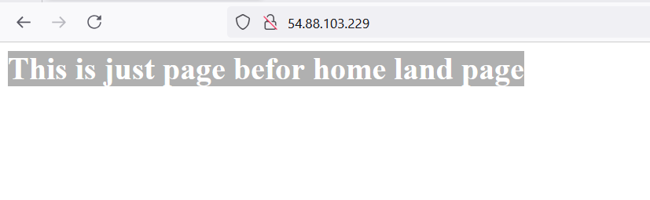

Need to add new index.html page

Step 8: Now create target groups .(Just for grouping the server for audio and video)

- Select instance and name the targer group for video (grouping for video)
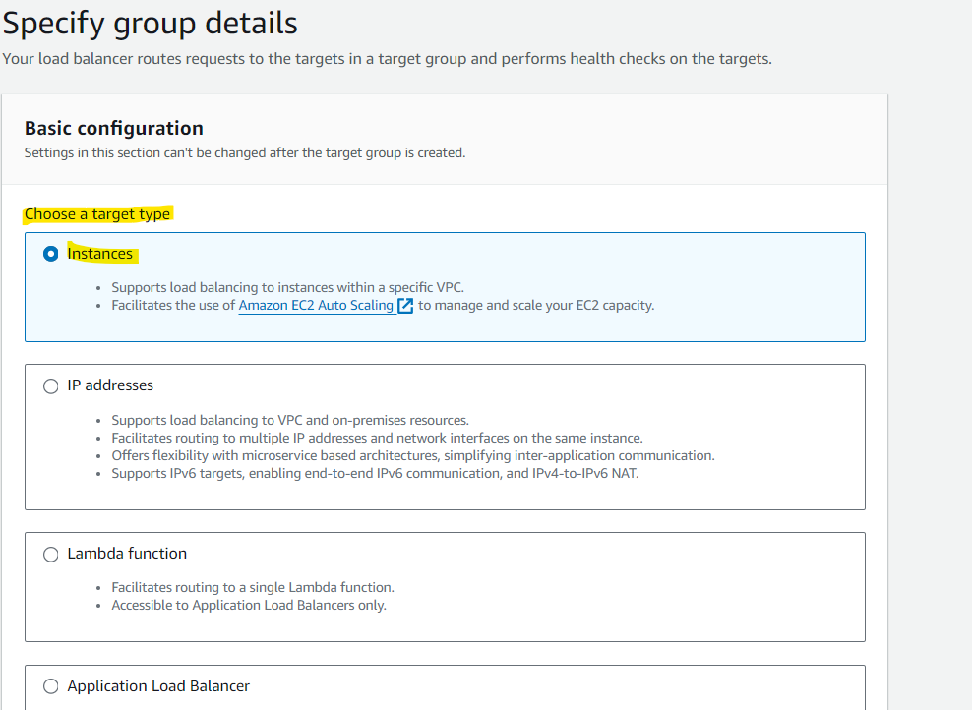

b.click on next button
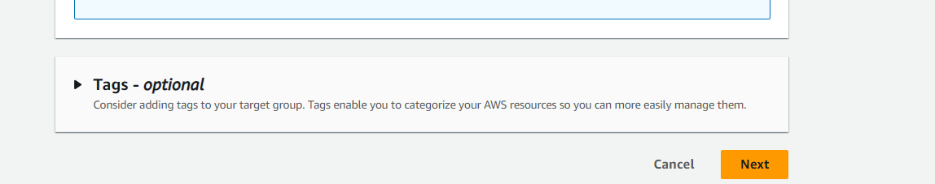

c.Now create on target group button

below screen shot for audio
same create for video

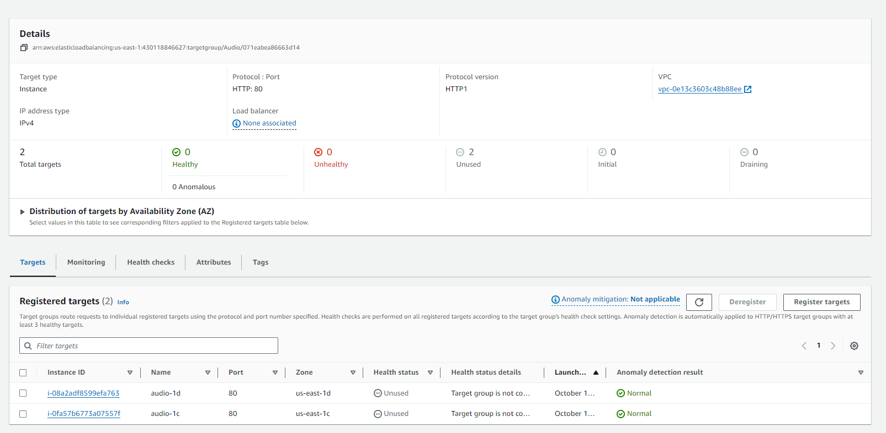

Video screen shot

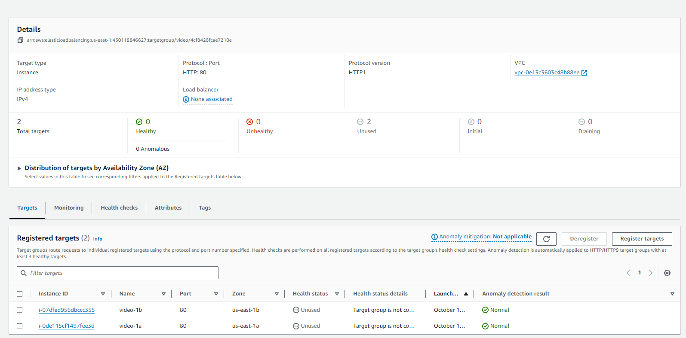

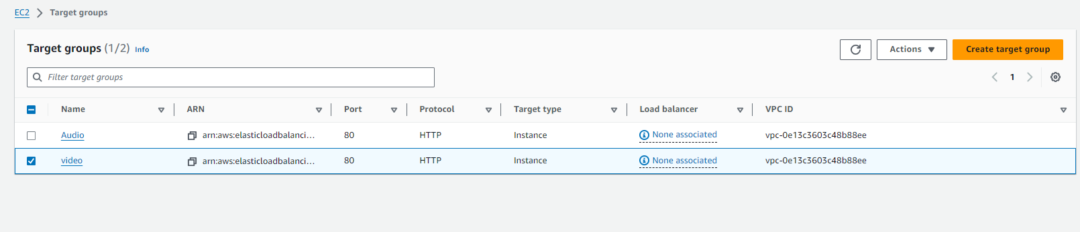
Step 9: Create Application Load Balance

a.)Provide name for ALB

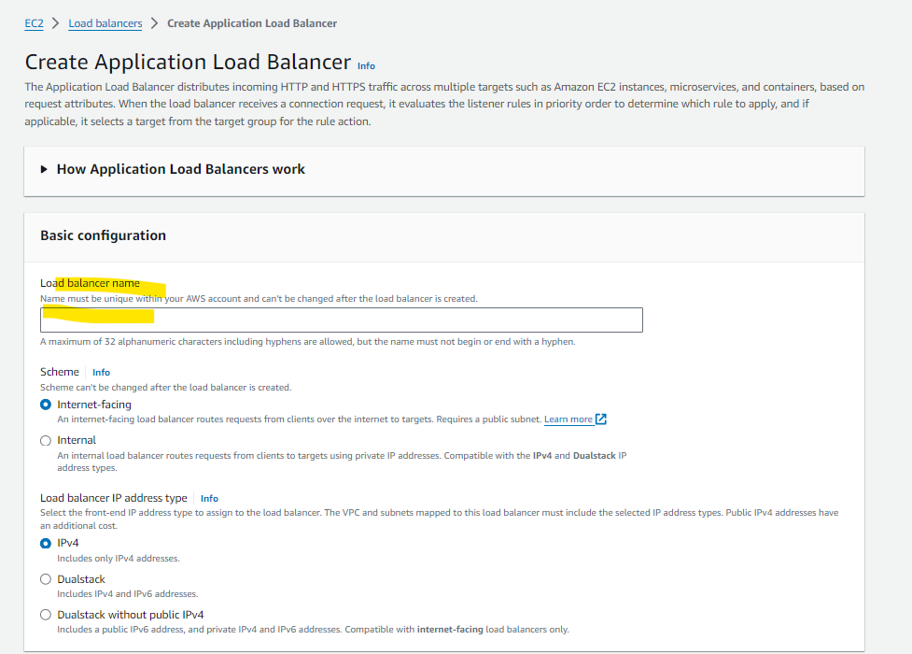

b)
Select Your vpc all subnet along with SG

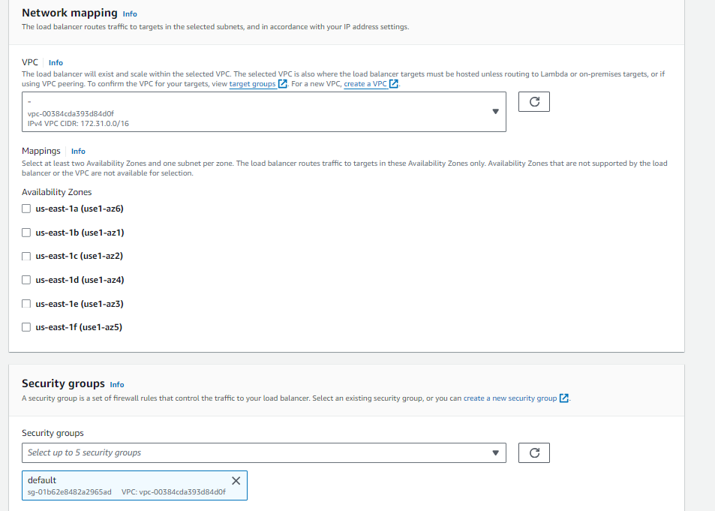

c.) Click on load balancer button

Step 10: Now click on load balancer name

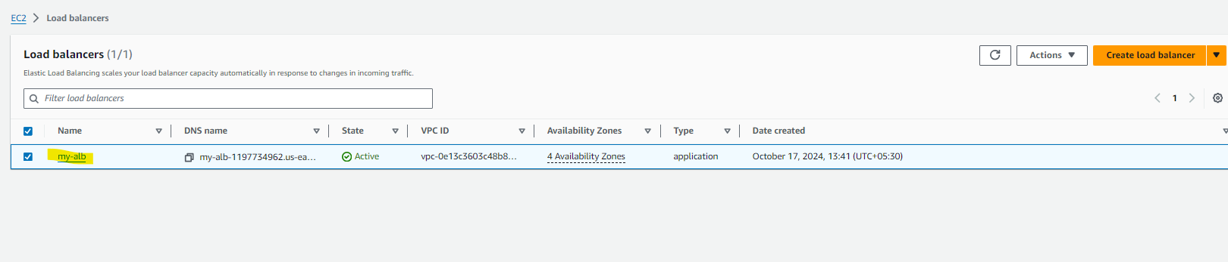
Go inside load balancer and click on Tab Listener and rule

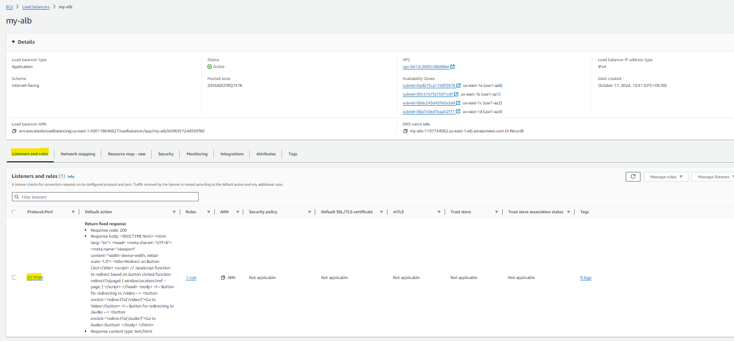

Now click on protocol port

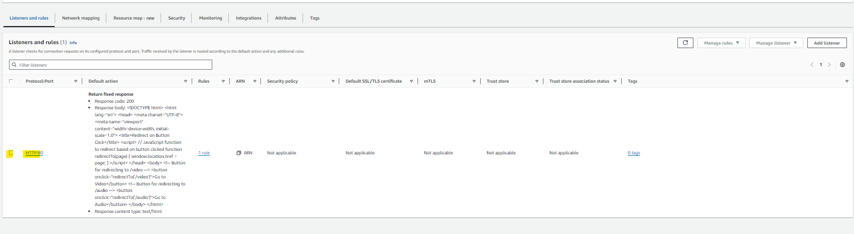

Click on Manages Rule--Edit Rule

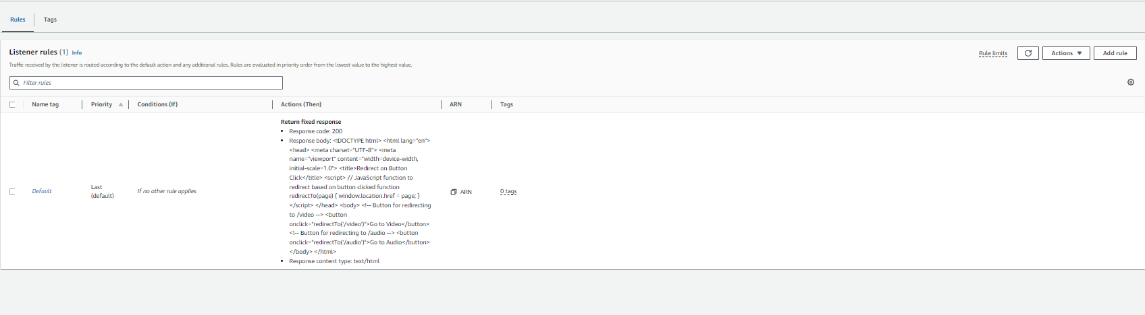

Again click on check box on Rule tab and click on ActionEdit button

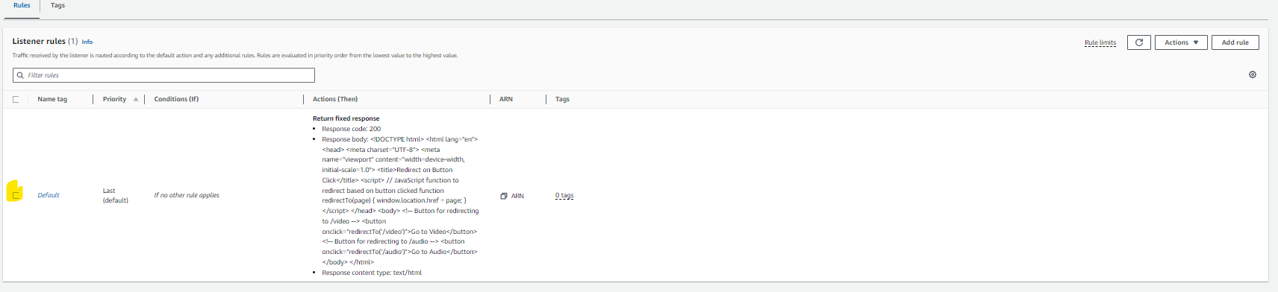

Now update the data as on highlighted shown asme need to update

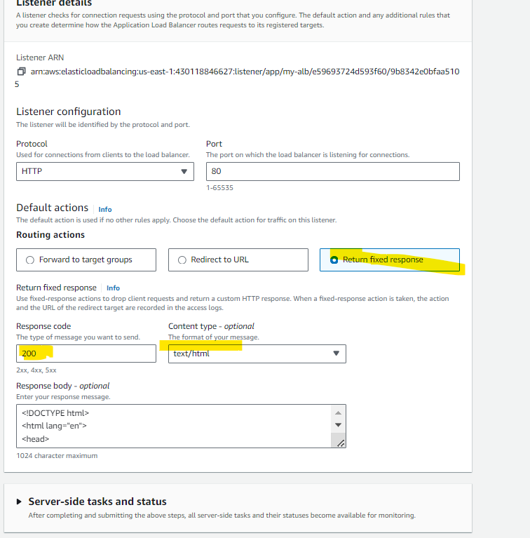

And in Response body add below code

<!DOCTYPE html>
<html lang="en">
<head>
<meta charset="UTF-8">
<meta name="viewport" content="width=device-width, initial-scale=1.0">
<title>Redirect on Button Click</title>
<script>
// JavaScript function to redirect based on button clicked
function redirectTo(page) {
window.location.href = page;
}
</script>
</head>
<body>

<!-- Button for redirecting to /video -->
<button onclick="redirectTo('/videos')">Go to Video</button>

<!-- Button for redirecting to /audio -->
<button onclick="redirectTo('/audios')">Go to Audio</button>

</body>
</html>

And click on save button

Step 11: Now select dns and hit on browser

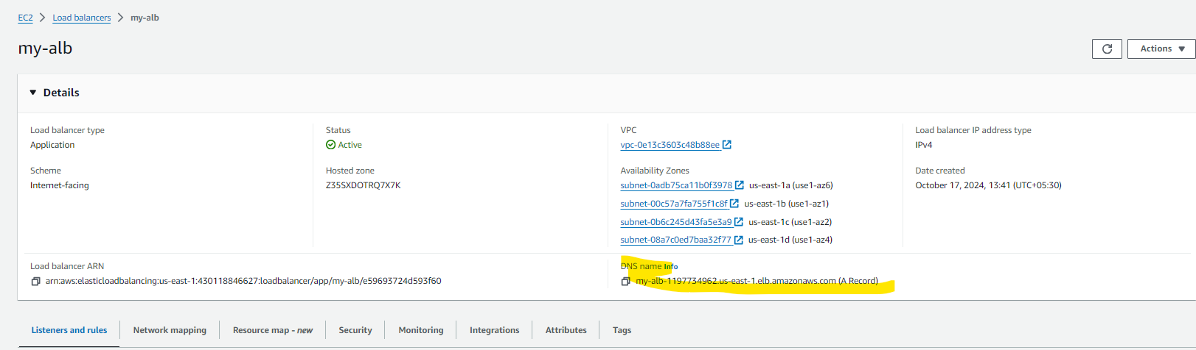

Below is look like this

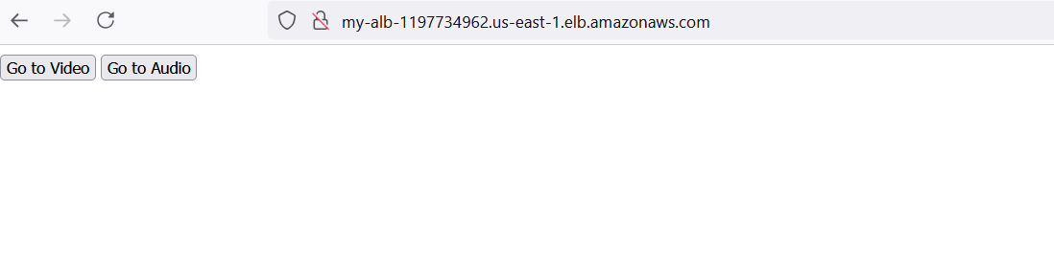

Now click on video button now url look like this

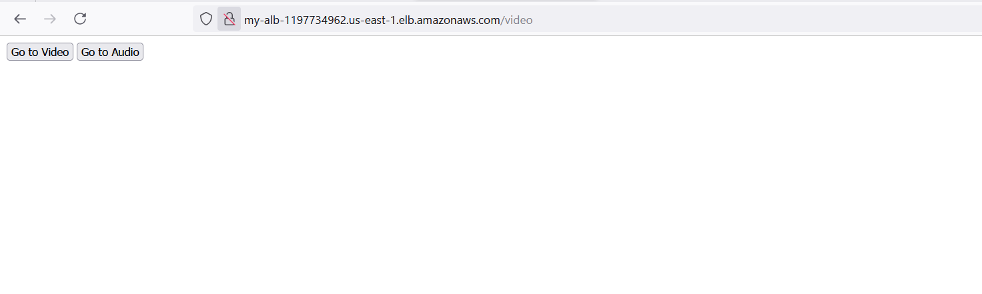

Page populated to video home page

Step 12: Now add rule for audio and videos in we have (/videos/assas or /audios/xyz) in this case

Now go to Manage rules-Add rule

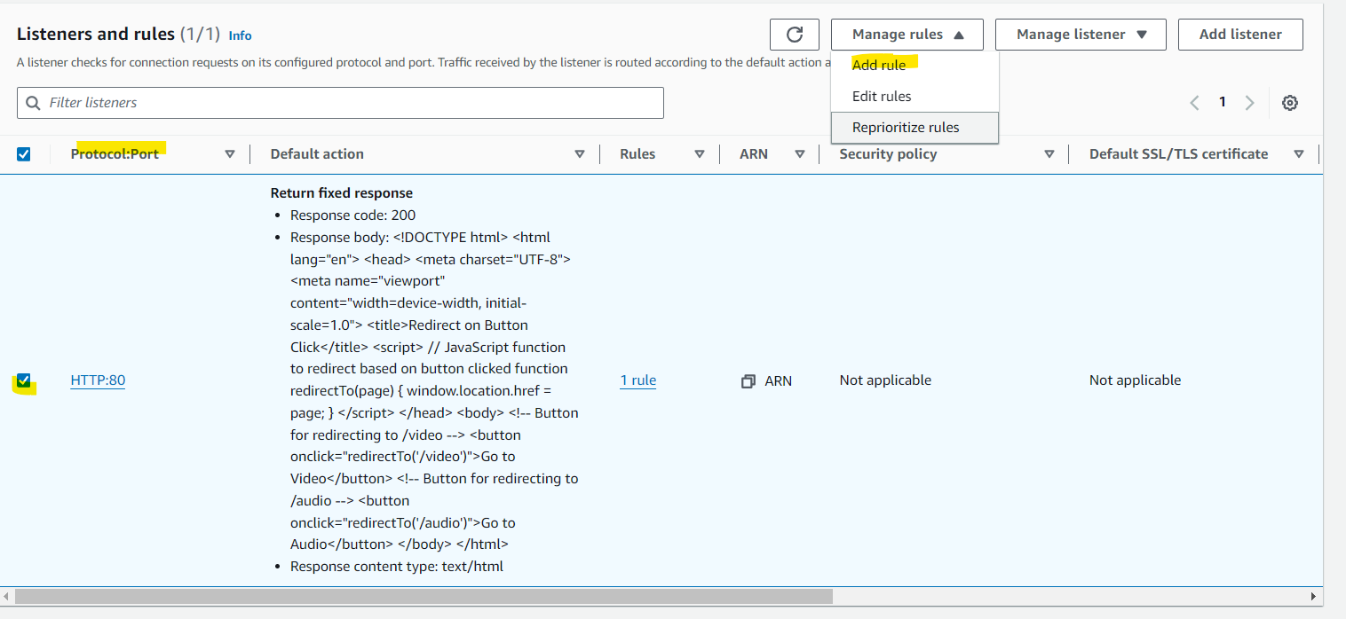

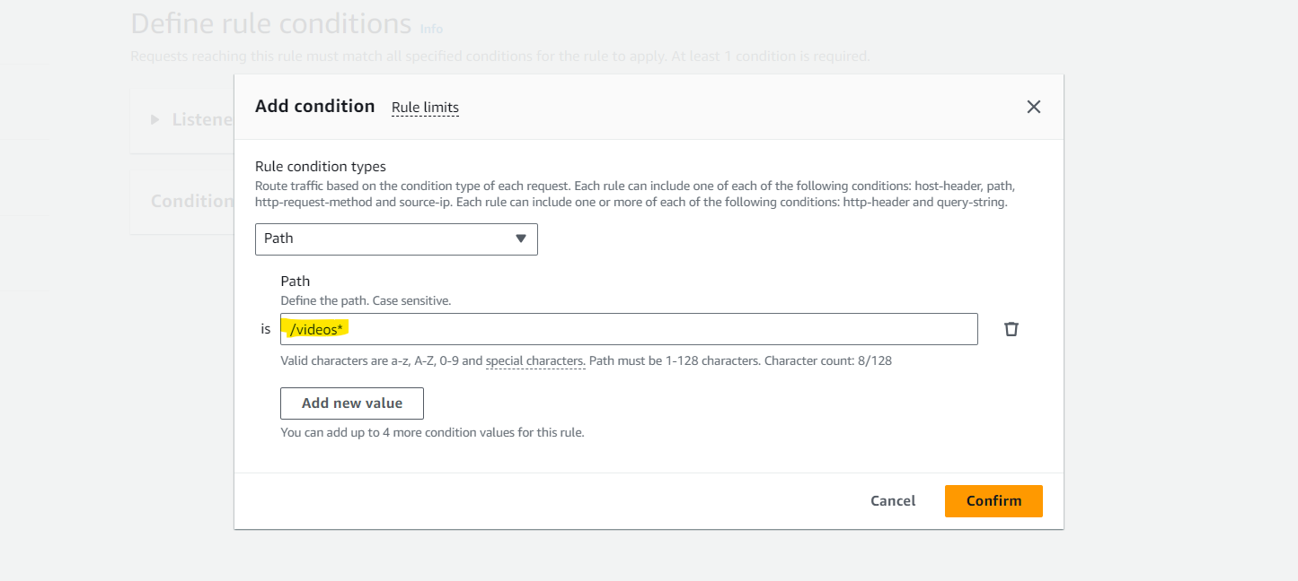

Path name given same as whatever directory created on server i.e videos

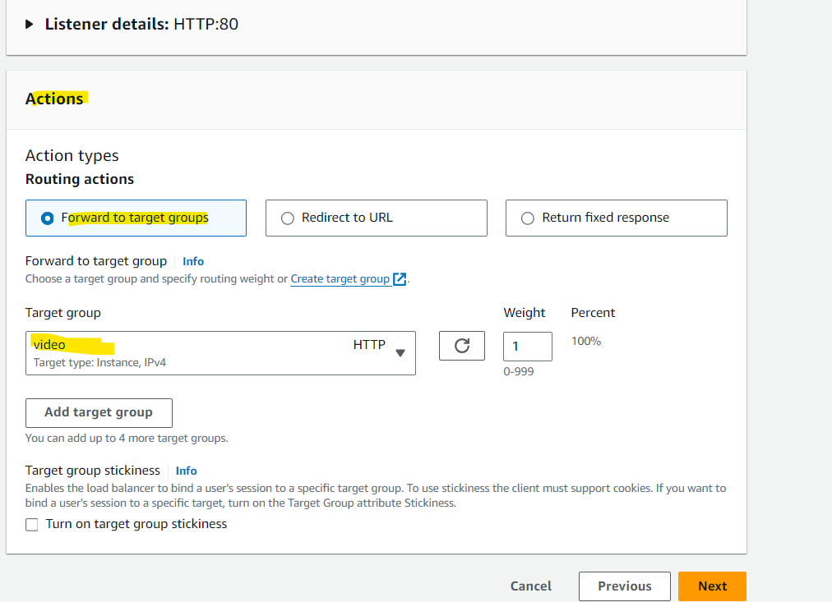

Same for audio

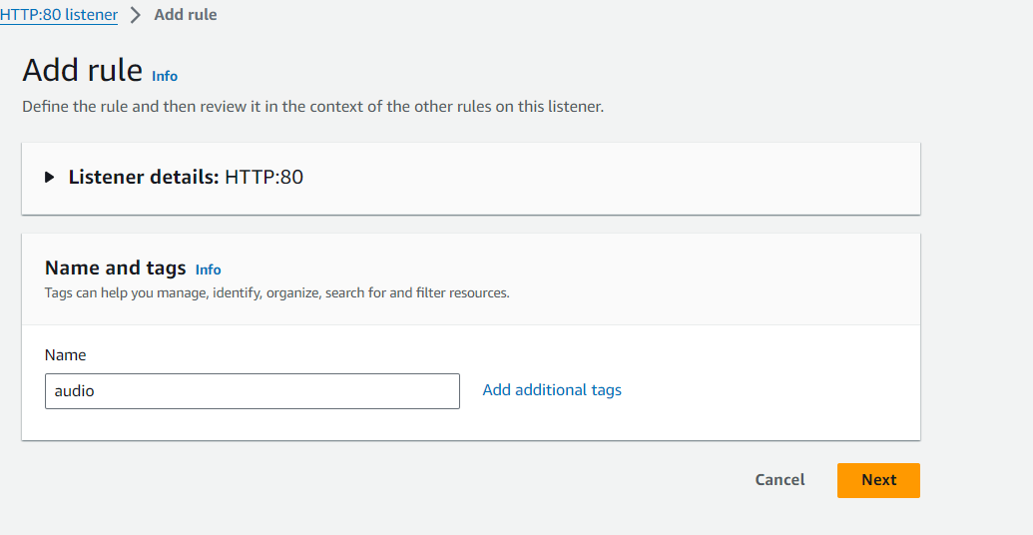

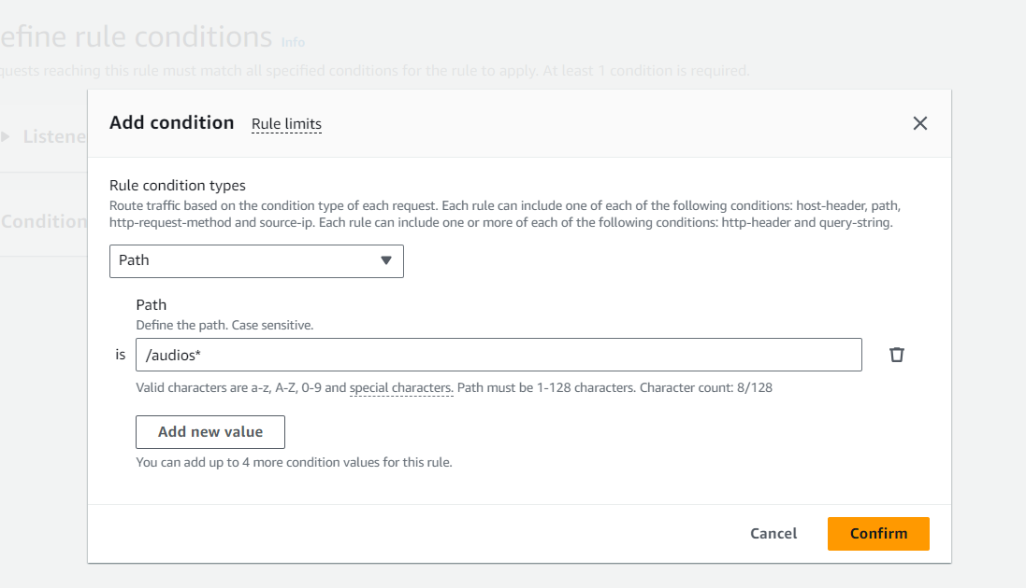

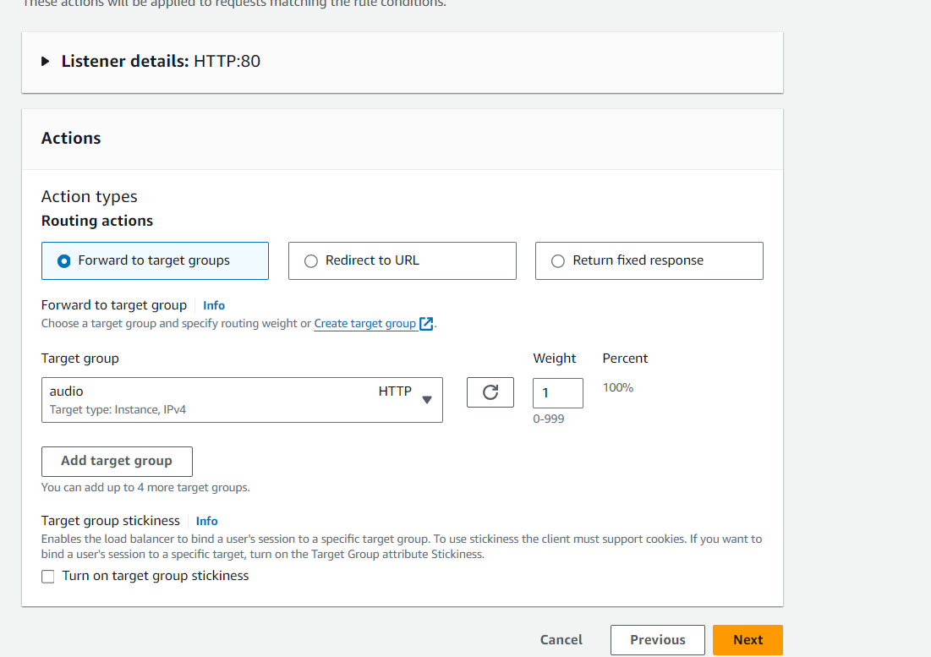

Step 13: Now launch dns of ALB

